                                                 Task 16-  ***Selenium Locators***

***Q1. write selenium script →open Firefox browser→maximizes the browser window→***

***navigates to "***[***http://google.com***](http://google.com)***” →prints the URL of the current page→ reloads the page →and closes the browser.***

***Code:***

***package com.firefox;***

***import org.openqa.selenium.By;***

***import org.openqa.selenium.WebDriver;***

***import io.github.bonigarcia.wdm.WebDriverManager;***

***import org.openqa.selenium.firefox.FirefoxDriver;***

***public class Firefoxbrowser {***

***public static void main(String[] args) {***

***//set geckoDriver path***

***System.setProperty("webdriver.gecko.driver","F:\\geckodriver-v0.33.0-win32\\geckodriver.exe" );***

***//create new FireFox instance***

***WebDriver driver = new FirefoxDriver();***

***//maximize the browser window***

***driver.manage().window().maximize();***

***//navigate to google***

***driver.get("https://www.google.com/");***

***//Print the current URL page***

***System.out.println("current url"+driver.getCurrentUrl());***

***//Reload the current page***

***driver.navigate().refresh();***

***//close the browser***

***driver.quit();***

***}***

***}***

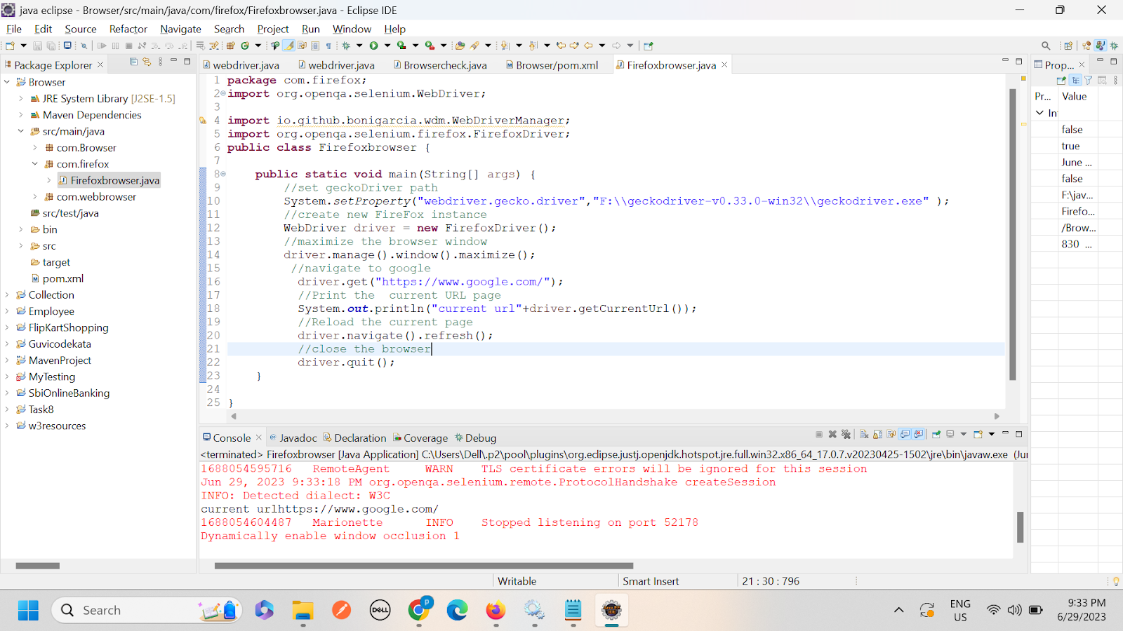

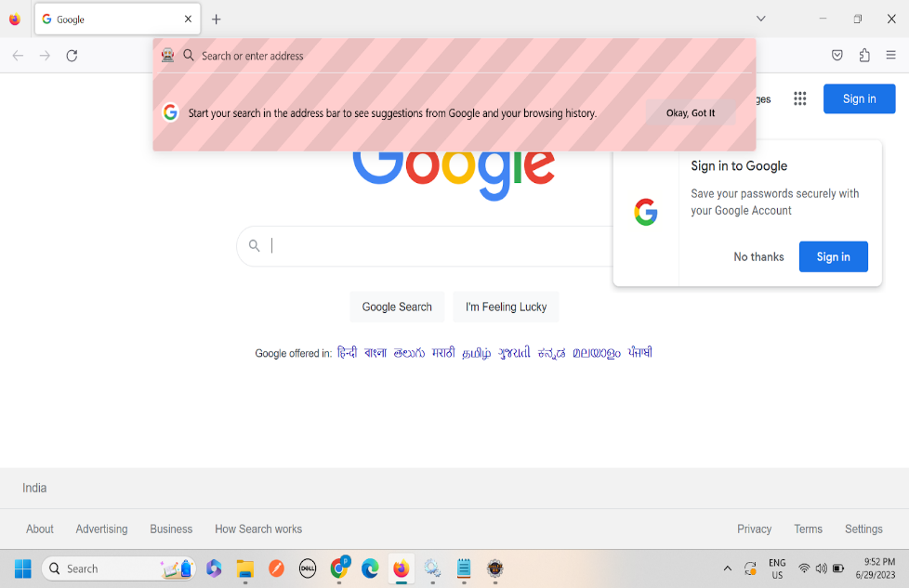

***2. Write a Selenium Java script →opens the Chrome browser→ navigates to "***[***https://www.demoblaze.com/"***](https://www.demoblaze.com/%22--)***→maximizes the browser window***

***→verifies if the title of the page is "STORE" →and prints "Page landed on correct website" if the title matches, else prints "Page not landed on correct website".***

***Code:***

***package com.firefox;***

***import org.openqa.selenium.WebDriver;***

***import org.openqa.selenium.chrome.ChromeDriver;***

***import io.github.bonigarcia.wdm.WebDriverManager;***

***import org.openqa.selenium.firefox.FirefoxDriver;***

***public class ChromeBrowserTest {***

***public static void main(String[] args) {***

***//set geckoDriver path***

***System.setProperty("webdriver.chrome.driver",***

***"F://chromedriver_win32//chromedriver.exe");***

***//create new FireFox instance***

***WebDriver driver=new ChromeDriver();***

***//maximize the browser window***

***driver.manage().window().maximize();***

***//navigate to demoblaze***

***driver.get("https://www.demoblaze.com/");***

***// verify if the title of the page is "STORE" and print the message***

***String PageTitle=driver.getTitle();***

***if(PageTitle.equals("STORE")) {***

***System.out.println("page landed on the correct website");***

***}***

***else {***

***System.out.println("page not landed on the correct website");***

***}***

***}***

***}***

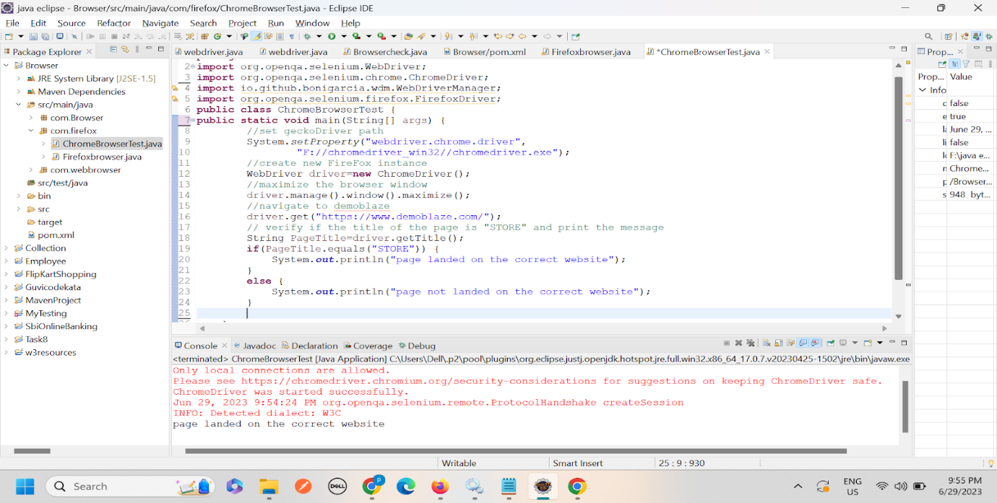

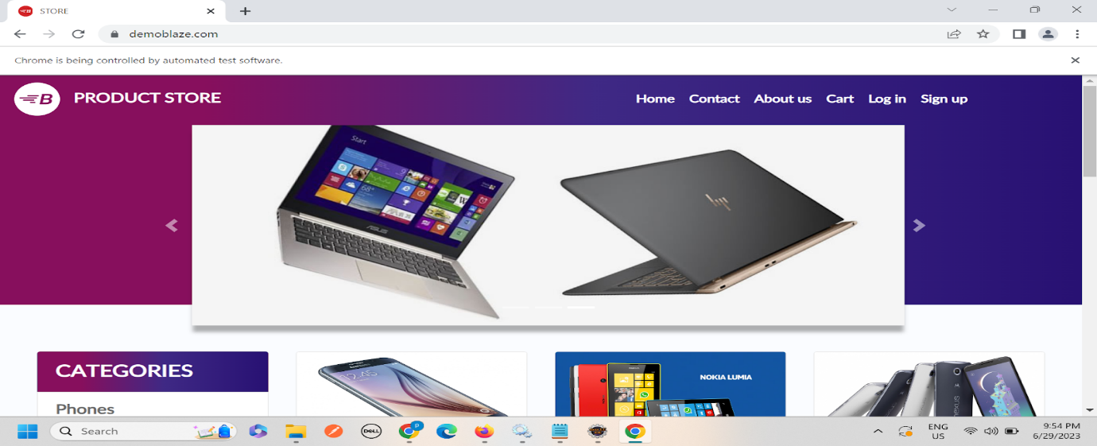

***3. Write a Selenium Java script →opens the chrome browser→navigates to "***[***https://www.wikipedia.org/***](https://www.wikipedia.org/)***" →maximizes the browser window→searches for the query "Artificial Intelligence", clicks on the "History" section in the search results, and prints the title of the section.***

***Code:***

***package com.ChromeBrowsersearch;***

***import org.openqa.selenium.By;***

***import org.openqa.selenium.WebDriver;***

***import org.openqa.selenium.WebElement;***

***import org.openqa.selenium.chrome.ChromeDriver;***

***import io.github.bonigarcia.wdm.WebDriverManager;***

***import org.openqa.selenium.firefox.FirefoxDriver;***

***public class ChromeBrowserSearch {***

***public static void main(String[] args) {***

***//set geckoDriver path***

***System.setProperty("webdriver.chrome.driver",***

***"F://chromedriver_win32//chromedriver.exe");***

***//create new FireFox instance***

***WebDriver driver=new ChromeDriver();***

***//navigate to WikiPedia***

***driver.get("https://www.wikipedia.org/");***

***//maximize the browser window***

***driver.manage().window().maximize();***

***//search  "Artificial Intelligent"***

***WebElement SearchInput=driver.findElement(By.name("search"));***

***SearchInput.sendKeys("Artificial Intelligent");***

***SearchInput.submit();***

***//Click on the "History"***

***WebElement historyLink = driver.findElement(By.xpath("//*[@id=\"mw-content-text\"]/div[4]/div[4]/ul/li[1]/table/tbody/tr/td[2]/div[1]/a"));***

***// WebElement historyLink1 = driver.findElement(By.xpath("//a[@href='/wiki/Artificial_intelligence']")).click();***

***historyLink.click();***

***//***

***// Print the title of the section***

***WebElement sectionTitle = driver.findElement(By.id("firstHeading"));***

***System.out.println("Section Title: " + sectionTitle.getText());***

***// Close the browser***

***//driver.quit();***

***}***

***}***



